House of Lancaster House of York
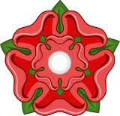 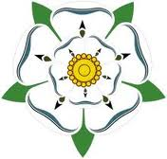
Elizabeth
of York

House of Tudor
Henry VII
(Henry Tudor)
Henry VII
(Henry Tudor)
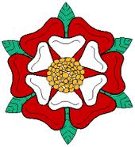
(survived)
3
1
2
4
5
6

Henry VIII
(divorced) (executed) (died) (annulled) (executed)
Katherine
Howard
Catherine
Parr
Catherine
of Aragon
Anne
of Cleves
Jane Seymour

Anne Boleyn

Edward VI

Elizabeth I
Mary I
(Bloody Mary)
Line of Succession:
Edward VI Mary I Elizabeth I

House of Tudor
Elizabeth
of York

Henry VII
(Henry Tudor)

- First-born son of Henry Tudor and Elizabeth—heir to the throne
- Married Catherine of Aragon (alliance with Spain) in 1501
- Died at 16 in 1502
- Married Louis XII of France (he died less than 3 mos. later)
- Married Charles Brandon, Duke of Suffolk
- Their granddaughter: Lady Jane Grey
- Married James IV of Scotland (Stewart)
- Son, James V of Scotland, married Mary of Guise (France).
- Gave birth to Mary, Queen of Scots (1542-1587)
- Gave birth to James VI of Scotland who became James I of England in 1603, succeeding Elizabeth I (his father: Henry Stuart, Lord Darnley—thus beginning the Stuart Dynasty)
- Married Arthur’s widow, Catherine of Aragon , in 1509
- Married six times total (see opposite page.)
Legitimate children:
- Mary I (1516-1558)
by Catherine of Aragon
- Elizabeth I (1533-1603)
by Anne Boleyn
- Edward VI (1537-1553)
by Jane Seymour
Henry VIII
(1491-1547)

Margaret Tudor
(1489-1541)

Mary Tudor
(1496-1553)

Arthur Tudor
(1486-1502)

